CLIFTON SUSPENSION BRIDGE

BRIDGE

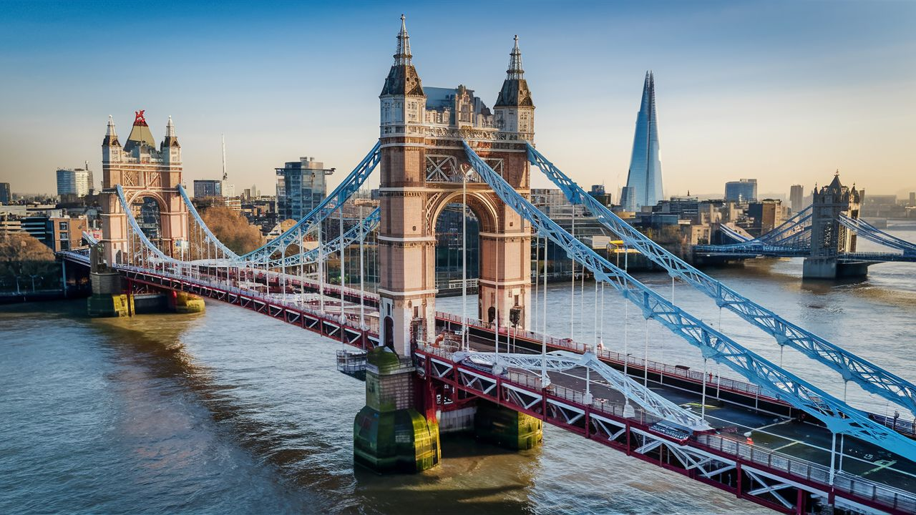

The Clifton Suspension Bridge, an iconic symbol of Bristol, England, spans the picturesque Avon Gorge, connecting the neighborhoods of Clifton and Leigh Woods. Designed by the famed engineer Isambard Kingdom Brunel, the bridge was completed in 1864, several years after Brunel's death. Its elegant design features a series of massive stone towers supporting sturdy iron chains, from which the bridge deck is suspended. The Clifton Suspension Bridge stretches approximately 214 meters (702 feet) across the gorge, with a height of 76 meters (245 feet) above the water below.

The bridge's construction posed significant engineering challenges, as it had to span a deep and narrow gorge while accommodating heavy traffic and withstanding the region's strong winds and tidal forces. Brunel's innovative design, combining the strength of iron chains with the stability of stone towers, proved to be both elegant and effective, making the Clifton Suspension Bridge a triumph of Victorian engineering.

Today, the Clifton Suspension Bridge is not only a vital transportation link but also a beloved landmark and popular tourist attraction. Visitors flock to its vantage points to admire the panoramic views of the Avon Gorge and the city of Bristol beyond. Whether illuminated by the golden light of sunrise or bathed in the glow of sunset, the bridge captivates with its timeless beauty and sense of grandeur.